**PROJECT NAME:** TRAFFIC SIGNS CLEANING

**TEAM MEMBERS:** Abdalla Ahmad, Abdulrahman Ahmad, Musaad Alkhaldi, Mohammed Alshammari, Abdullah Altamimi, Saad Kandari

**CLASS:** ME 476C

**SUBJECT:** FINAL REPORT

**DATE:** MAY 1ST, 2020

# DISCLAIMER

This report was prepared by students as part of a university course requirement. While considerable effort has been put into the project, it is not the work of licensed engineers and has not undergone the extensive verification that is common in the profession. The information, data, conclusions, and content of this report should not be relied on or utilized without thorough, independent testing and verification. University faculty members may have been associated with this project as advisors, sponsors, or course instructors, but as such they are not responsible for the accuracy of results or conclusions.

Table of Contents

DISCLAIMER 2

1 BACKGROUND 5

1.1 Introduction 5

1.2 Project Description 5

1.3 Original System 5

2 REQUIREMENTS 6

2.1 Customer Requirements (CRs) 6

2.2 Engineering Requirements (ERs) 7

2.3 Functional Decomposition 8

2.3.1 Black Box Model 8

2.3.2 Functional Model 9

2.4 House of Quality (HoQ) 11

3 TESTING PROCEDURES (TPs) 14

3.1 Testing Procedure 1: Flight Time 14

3.1.1 Testing Procedure 1: Objective 14

3.1.2 Testing Procedure 1: Resources Required 14

3.1.3 Testing Procedure 1: Schedule 14

3.2 Testing Procedure 2: Height of Flight 14

3.2.1 Testing Procedure 2: Objective 14

3.2.2 Testing Procedure 2: Resources Required 14

3.2.3 Testing Procedure 2: Schedule 15

3.3 Testing Procedure 3: Water Tank 15

3.3.1 Testing Procedure 3: Objective 15

3.3.2 Testing Procedure 3: Resources Required 15

3.3.3 Testing Procedure 3: Schedule 16

3.4 Testing Procedure 4: Device Weight 16

3.4.1 Testing Procedure 4: Objective 16

3.4.2 Testing Procedure 4: Resources Required 16

3.4.3 Testing Procedure 4: Schedule 16

3.5 Testing Procedure 5: Reliable in Temperature 16

3.5.1 Testing Procedure 5: Objective 16

3.5.2 Testing Procedure 5: Resources Required 17

3.5.3 Testing Procedure 5: Schedule 17

3.6 Testing Procedure 6: Durable 17

3.6.1 Testing Procedure 6: Objective 17

3.6.3 Schedule 18

4 RISK ANALYSIS AND MITIGATION 19

4.1 Critical Failures 20

4.1.1 Potential Critical Failure 1: Motor winding burning 20

4.1.2 Potential Critical Failure 2: Motor insulation burning 20

4.1.3 Potential Critical Failure 3: Motor wire 20

4.1.4 Potential Critical Failure 4: Arduino Board 21

4.1.5 Potential Critical Failure 5: Arduino Pins 21

4.1.6 Potential Critical Failure 6: Arduino Connection 21

4.1.7 Potential Critical Failure 6: Battery Burning 21

4.1.8 Potential Critical Failure 7: Battery Low Voltage 21

4.1.9 Potential Critical Failure 7: Controller Burning 21

4.1.10 Potential Critical Failure 7: Controller Body Breaking 22

4.2 Risk and Trade-offs Analysis 22

5 DESIGNS SELECTED 23

5.1 Design Description 23

5.1.1 Rationale for Design Selection 23

5.2 Implementation Plan 25

6 REFERENCES 27

7 APPENDICES 28

APPENDIX A – DESIGN CALCULATIONS 28

APPENDIX B – FMEA 29

# 1 BACKGROUND

## 1.1 Introduction

Traffic signs play an important role in controlling the traffic and reducing the accidents happens on the highway. Traffic signals indicate which lane need to stop and which traffic lane can go, while traffic signs identify where you are heading, what are the directions to the destination, speed limits define on the signs, instructions given for the prohibited things, miles to reach the destination defines, etc. Traffic signs and signals always hang at high places like poles where it can clearly see from far distance and drivers can reduce the speed for stopping or become alert and drive carefully from that point or follow the instructions define on the signs. Traffic signs always uses sharp color which can clearly see from the long distance. With all these features, traffic signs are quite important for the motorists but as the traffic signs hangs on the highways and roads openly so after sometime sign boards become dirty because of pollution and reading the signs boards become difficult and traffic signs get dim. For that situation it is necessary to clean the sign boards after some interval to make the traffic signs clear for the drivers and keep the highways safe. The contemporary issues define by this project was to clean the traffic signs, this is the first issue, second issue is that big machines use to clean the traffic signs but they block all the traffic on that route and it keep the traveler facing lot of issues, and third issue is that the device to clean the sign board must be safe to use, so safety is another problem define in this project.

This project is to design a device which can clean the traffic signs without interrupting the traffic flow. The main objectives of this project is to keep the traffic continually working, the device is safe to use and it must be failsafe.

This project interest the sponsor because of the fact that there is no such device available in the market for this purpose and it is necessary to invent such device which clean the sign boards without interfering the traffic and this thing interest the sponsor to work on. This project will be beneficial for the sponsor as sponsor can utilize the design for commercial purpose and the stakeholders like drivers, motorists, and public who travel on highways can travel safely and read the sign boards easily, it will help them in many ways during the travelling. This project is important as it will be beneficial for the public and will keep them safe.

## 1.2 Project Description

The project defines as to innovate a device that can clean traffic signs without interrupting the flow of traffic. It has to be operated remotely and it must be reliable and safe to use. It must possess the failsafe condition and the accuracy of the system must be high and it should be eco-friendly as well. During the cleaning water must not fall on the highways.

## 1.3 Original System

Our project is original system and there is no other project developed before when this project has started.

# 2 REQUIREMENTS

The project requires from the team to design a systematic device which can clean the traffic signs on the highways without disturbing the traffic flow. And the device need to be safe to operate and failsafe condition must be present in it. The team will design the device according to the given description of the project. In this chapter, the project description will describe in the form of customer requirements in tabular way, and then engineering requirements devised from the customer requirements. After that QFD will develop to define the relation between CRs and ERs and then identify the most important engineering requirement till the least engineering requirement in a sequence.

## 2.1 Customer Requirements (CRs)

Customer requirements are the project description in a tabular form which contains all the important points of the project define by the client. The purpose of making the customer requirements table is to highlight the main part of the project so that when the project will be ready it can clearly examine through the customer requirement whether the objectives of the project have achieved or not. Another reason to do the customer requirements I to understand the project because sometime the project description is not clear enough to understand the project so customer requirement helps at that time. The customer requirement for this project has been given in the table 1.

Table 1: Customer Requirements

|  |  |
| --- | --- |
| **Customer Requirements** | **Weightage** |
| Do not interrupt the flow of traffic | 9 |
| Failsafe | 8 |
| Collect Water Drops | 7 |
| Clean in short time | 6 |
| Clean without damaging the coating | 5 |
| Safe to Operate | 4 |
| Cost within budget | 3 |
| Durable and Robust Design | 2 |
| Reliable Design | 1 |

Do not interrupt the flow of traffic requirement is meeting the objective as it has asked to develop such design which cannot interrupt the traffic flow so it is directly meting the objective. Failsafe is also the highlighted point in the description so it is meeting the objective as well. Collect water drops, meets the objective as the cleanliness can perform through the water. Short time cleaning meets the objective as to perform the task in quick way according to the objective of project. Clean without damaging the coating meet the objective that state safe to use without causing any trouble, safe to operate the device meet the objective of safe to use, cost within budget is a necessary requirement because budget has given so it must be within that budget and that’s the regular objective of any design project, durable and robust design meet the objective as it is necessary for the design to be long lasting and can easily move from one place to another place so it is meeting the objective of safe to use. Reliable design meets the objective as it need to work all the time in all the conditions.

## 2.2 Engineering Requirements (ERs)

Engineering requirements are the one which developed from the customer requirements and these are the technical details about the project so that the project can develop using these physical values and these physical values can test through different procedures when the product will develop. Table 2 has shown the engineering requirements generated for this project.

Table 2: Engineering Requirements

|  |  |  |  |
| --- | --- | --- | --- |
| **Engineering Requirements** | **Target Values** | **Tolerance** | **Justification** |
| Flight Time | 20 minutes | $$± 5$$ | 20 minutes have given, 5 minutes tolerance so that it can work easily in that limit |
| Height of Flight | 20 feet | $$± 5$$ | Minimum height is 15 feet so tolerance is 5 feet above this value and target value is 20 feet |
| Water tank | 3 liter | $$± 2$$ | 3 liter of water is enough to clean board, and 2 liter of tolerance can easily work for it |
| Device Weight | 2 kg | $$± 1$$ | 2 kg of device is enough to lift up and 1 kg of tolerance to bear the extra load |
| Reliable in temperature | -10C to 40C | $$± 5$$ | High range of temperature variation can wear in this range with tolerance of 5 degrees at each point |
| Durable | 2200 GPa | $$± 200$$ | Bear the shear stress of 2200 GPa to show durability, 2200 GPA is high value so tolerance range is high as 200. |

Flight time is the time to keep the device in the air and that is necessary for the device because it takes around 10 to 15 minutes to clean a board so the range of 20 minutes flying is enough for cleaning. Height of flight is defining the height that will take off by the system and the product will fly above the defined height and if the board is lower than the 15 feet, it will not clean through this system.

Water tank carrier is basically carrying capacity of the device for the water, and this would be 3 liters which is enough to clean the boards.

Device weight is basically the weight of the device that will carry by the device itself during the flying and the weight is 2 kg maximum so it can easily lift up in the air and fly.

Reliable in temperature means the device can withstand again harsh temperature either in cold season when temperature goes below 0 degrees or in summer season when temperature goes above 30 degrees. The device must be reliable in such a range of temperature.

Durable means the device must be strong and for this purpose it should have the shear stress of 2200 GPa so that it will not easily break in any condition.

## 2.3 Functional Decomposition

The project is to clean the traffic signs boards, and it need not to interrupt the flow of traffic as well so in that situation the functional operation of this project will consist of controller which control the main product, that product will reach near to the sign board and it will fly up in the air to clean the board and then will return to the starting point. The cleaning function will consist of a wiper that will dip into the water and scroll that wiper over the sign board to make it clean without putting the water on the ground surface. This was the main functionality of this project, while the functional decomposition for any project consists of two types, one is the black box, and second is the functional model. The black box defines the inputs and outputs of the system without interfering inside the system, and functional model describe the complete process of the input to reach to the output. In the functional model, all the subsystem defines together.

### 2.3.1 Black Box Model

The black box model is basically a model which defines only the inputs and outputs of the system and it has nothing to do with the internal functionality of the system and that is why the name has given to it as the back box. Because what is inside the box is of no interest in black box model, it only sees what we will provide to the system and what we will get from the system. The inputs and outputs consist of material input, energy input and signal input and vice versa for the output. The black box model has shown below

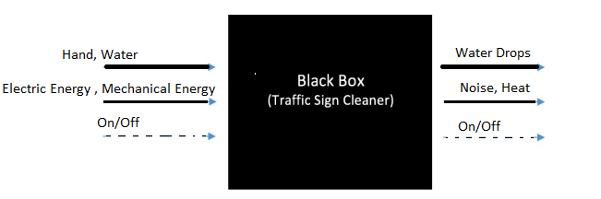

Figure 2: Black Box Model

In the above black box model, human hand and water are the materials uses as the input, hand to control the controller and water to use for cleaning, while for the energy, electrical energy and mechanical energy are using to perform the action, and the signal of the device as the input is either on or off. In the same way, output is showing that the material is water drops while cleaning, in the energy noise and heat will release, and signal is either on or off. It has helped the team in understand the project basic functionality, as through this model it is clear that we will use a controller for performing the task, some water drops will fall down on the ground as the output along with the clean sign board.

### 2.3.2 Functional Model

The functional model describes the complete functionality of the system which can expect after the product will implement. In the functional model all the subsystems will define for the project. The functional model has shown below in the figure.

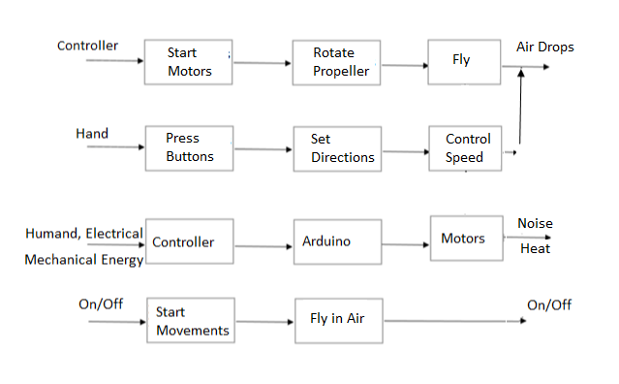

Figure 3: Functional Model

The above functional model contains the subsystems like

* Motors
* Propellers
* Arduino
* Controller

From this functional model it is easy to understand what will be the functionality of device what we will going to implement. As the complete process has described from starting the motor till the cleaning so this clears the understanding of project.

## 2.4 House of Quality (HoQ)

House of Quality is a chart which describe the relationship between the customer requirements and engineering requirements through a matrix. It is a matrix form, where top side of matrix contains the engineering requirements, left column contains the customer requirements and relating each customer requirement with the engineering requirement and fil their corresponding box with the value that shows the dependency, the dependency can be high and large number will put in that else leave the box. In this way the matrix form and then calculate the absolute importance from the matrix using the weightage values and then relative technical importance for each engineering requirement. In this way the engineering requirement can enlist from the top priority to the least priority. Following figure has shown the House of Quality

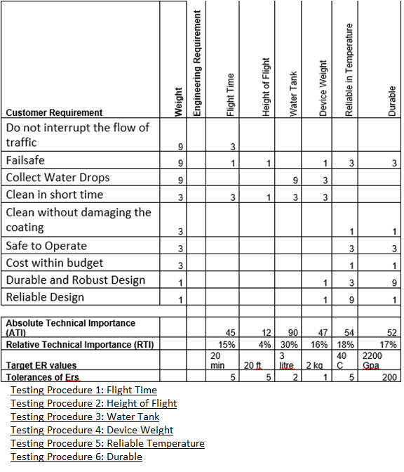

Figure 4: House of Quality (HoQ)

Results of HoQ has shown that the most important engineering requirement is water tank which need to carry with the device for cleaning purpose, and the second most important is reliable in all the weather conditions, third is durable, fourth is device weight, fifth is flight time, and sixth is height of flight.

2.5 Standards, Codes and Regulations

The Standards, Codes, and Regulation that applied

A list of standard used in the project has given below while the complete details have provided in the following table.

* American Society of Testing and Materials (ASTM)
* Institute of Electrical and Electronics Engineers (IEEE)
* American Society of Mechanical Engineers (ASME)
* Aluminum Association (AA)
* American Gear Manufacturers Associations (AGMA)
* American Welding Society (AWS)

These standards have described below in the table

Table 3: Standards applied to the project

|  |  |  |
| --- | --- | --- |
| **Standard Number or Code** | **Title of Standard** | **How it applies to Project** |
| ASTM | American Society of Testing and Materials | It is applying for the testing of materials that will use in the project to confirm that they will be reliable to use |
| IEEE | Institute of Electrical and Electronics Engineers | All the research in the project has conducted on the basis of IEEE and all the electrical components will consist of IEEE standards for safe and reliable use |
| ASME | American Society of Mechanical Engineers | The mechanical design and mechanical parts will follow ASME like motors to have reliable and safe products. |
| AA | Aluminum Association | For the reliable use of Aluminum if we use in the project structure |
| AGMA | American Gear Manufacturing Associations | The manufacturing of product will follow this standard for the safety of both human and prepare the safe product to use |
| AWS | American Welding Society | Welding may use in the project for joining the structural parts so the welding will perform on the basis of AWS, like will wear the safety products to do the welding. |

# 3 TESTING PROCEDURES (TPs)

In this section the testing procedures have described that will test each engineering requirement and see if the engineering requirement has fulfilled or not. The complete details will provide for each testing procedure against each engineering requirement. The testing procedures will define the objectives, resources required to perform the test and the schedule at which the test can perform.

## 3.1 Testing Procedure 1: Flight Time

Flight time is an important engineering requirement for this project because it will be the time taken by the drone to fly in the air and hence better the flight time will provide more options to clean the signs and can better clean the signs boards.

### 3.1.1 Testing Procedure 1: Objective

The purpose of performing this testing procedure is to find the time of drone it keeps in the air, flight time means the time it will stay in the air to do the cleaning and it is important to find this time because it will help in better cleaning. The required time will start from the fully charged drone to the discharge time. It has required that the flight time will be around 20 minutes, so the drone need to fly for more than 20 minutes in order to fulfill this engineering requirement.

### 3.1.2 Testing Procedure 1: Resources Required

The resources required to test the flight time consist of stopwatch, the stopwatch will use to find the time of drone kept in the air while the drone will fully charge and discharge during the flying. This resource is available in the mobile phone and it is also available in the labs as well so the team will use the mobile phone stopwatch app to measure the flight time of the drone.

### 3.1.3 Testing Procedure 1: Schedule

This testing will schedule in the July, when the project will be ready. Probably it will perform between July 15 to July 20, 2020 and it will perform in the afternoon. This test will take around half an hour and during this testing, some other tests will also perform.

## 3.2 Testing Procedure 2: Height of Flight

Height of flight is the peak height of drone form the ground and it is an engineering requirement which will test to see if the requirement has achieved or not. The requirement is to have the height of 20 feet so the test will determine if the drone can above 20 feet or not.

### 3.2.1 Testing Procedure 2: Objective

The objective of performing this test is to see if the engineering requirement has fulfilled by the product or not and to do so the height of flight will measure for the drone using the GPS or barometer. That already installs over the drone.

### 3.2.2 Testing Procedure 2: Resources Required

For finding the height of any object flying above from the ground, we need the GPS system or the barometer, both of these components can give the height of the object form the ground. GPS uses different methodology which is finding the object position from the satellite and then calculate the distance between the grounds and object to give the height of object while the barometer uses the concept of rays to detect the height of object from the ground. Another option to detect the height is to fly the drone along a long pole and determine the height through that pole by taking the pole as relative positioning of drone. In this test, we will use the pole to determine the height of drone and will compare that height with the barometer and GPS installed in the drone. In this way, height will verify from three methods. The pole method can use in our project for testing because we need the drone to fly at a limited height, the height requirement is around 20 feet, so we need the pole of 25 feet to see whether the drone can easily reach to 25 feet or not. And hence 25 feet long pole are easily available in the premises of university therefore this test can perform in the premises of university.

### 3.2.3 Testing Procedure 2: Schedule

This test will perform when the project will finish, and it will finish in July, so probably the test will perform in between July 15, to July 20, 2020, and it will perform in afternoon in the premises of university where a long pole is available.

## 3.3 Testing Procedure 3: Water Tank

The water tank is one of the important part of project and it will store the water to clean the sign boards, hence the water tank capacity is important factor in this case so it will test to see how much water tank can store the water in short it will determine the capacity of water tank that will attach to the drone. The required amount of water to store in the tank is 3 liters, so it will see if 3 liters can easily store in the tank or not.

### 3.3.1 Testing Procedure 3: Objective

The objective of performing this test is to find the capacity of water present in the water tank and determine that capacity, if the capacity is not enough the project is not useful for cleaning the sign boards, so the required amount is 3 liters and the water tank will contain more than 3 liter of water and it will test by finding the capacity of tank using the volume of water tank. Which can test by measuring the length, width and height of the tank.

### 3.3.2 Testing Procedure 3: Resources Required

The resources required to perform this test is only a small scale in inches, the scale should be of 12 inches’ maximum or even 6-inch scale is enough to perform this test. This scale is available in the labs as well as the team contain this scale so it will not need anything else to perform this test. To perform the, use the scale, measure the outer sides of tank, length, width and height and then multiply these three values to find the volume of the tank.

$$Volume=Lenght*Widht*Height$$

The returned volume will be cubic inches then it will convert into liters as

$$1 inches^{3}= 0.0163871 lilters$$

$$Volume (liters)=\frac{Volume (inches^{3})}{61.024}$$

Hence it will give the liters, the volume of water that reach to 3 liters is 200 cubic inches.

$$Volume=200 inch$$

$$Volume=3.27741 liters$$

Hence the water storage tank must be larger than 200 cubic inches

### 3.3.3 Testing Procedure 3: Schedule

This test will perform when the project will finish, and it will finish in July, so probably the test will perform in between July 15, to July 20, 2020, and it will perform in afternoon along with the other tests.

### 3.4 Testing Procedure 4: Device Weight

Weight of the device is another important factor in the device and it is also one of the important engineering requirement that must need to fulfill because the weight plays major role, if the weight is too much it will be difficult for the drone to carry lot of weight, as the water stand, water tank, and water will also include in the weight so measuring the weight is quite necessary for the product and the required weight is 2 kg maximum without the water.

### 3.4.1 Testing Procedure 4: Objective

The main objective of performing this test is to analyze the total weight of device including the water shower, tanks etc. This is important to find because a limited amount of weight can lift by drone and if the weight will increase, the lifting capacity need to increase for the drone which will increase the cost of product as it will use more powerful motors.

### 3.4.2 Testing Procedure 4: Resources Required

The resource required to perform this test is weight machine, which is easily available in the labs, mechanical lab has the weight machine so the team will use the machine from the lab and it will measure the weight. The device will take to the lab and after resetting the weight machine, and then place the final product on it. It will perform without any high pressure air passing around because it can tilt the device and the weight result will not be correct in that case.

### 3.4.3 Testing Procedure 4: Schedule

This test will perform when the project will finish, and it will finish in July, so probably the test will perform in between July 15, to July 20, 2020, and it will perform in morning in the mechanical lab.

## 3.5 Testing Procedure 5: Reliable in Temperature

The device will use on the roads in the open atmosphere so it is important that it must be resistant to different temperatures like in high temperatures and in low temperatures it will not face any trouble while working. This is an engineering requirement and it states that the device need to work in between -10 degrees to 40 degrees. This test can perform by placing the device in a cold storage environment to test the lowest temperatures and for highest temperatures it can place in the heated room where the temperature can raise to 40 degrees.

### 3.5.1 Testing Procedure 5: Objective

The objective of this test is to find that the device is resistant to high and low temperatures because it will work in the open atmosphere and the temperature can be too high or too low in some conditions so the device will not face any trouble during the working because of the temperature. The range required is from -10 degrees to 40 degrees, the device must perform above these temperatures as well. And this test can perform by placing all the components in the refrigerator and in the hot room.

### 3.5.2 Testing Procedure 5: Resources Required

The components required to perform this test are two, basically to test the device between the lowest temperatures, considering that the lowest temperatures ranges from -10 degrees to 5 degrees, while the highest temperatures ranges from 30 degrees to 40 degrees. While the middle temperature range can test in the room with room temperature. For the lowest temperature put the device in the refrigerator and set the temperatures to the lowest values but the problem here is to placing the device in the refrigerator because refrigerator is too small to put such device in that case we can put all the components from wires, to boards, to motors, to structural parts in the refrigerator before assembling, and then test the device, while perform the same actions in the highest temperatures. It would be better to perform this test before assembling the parts because it will not take more space and the test can perform easily.

### 3.5.3 Testing Procedure 5: Schedule

This test will perform when the project components will purchase and ready to assemble, and it will probably perform in between July 1, to July 5, 2020, and it will perform in morning in the lab and in the room.

## 3.6 Testing Procedure 6: Durable

The durability of any project tell the life span of that device and it also tells the reliability of product. The durability test can perform by testing the characteristics of system functions and see how the systems have performed under specific conditions to declare it durable.

### 3.6.1 Testing Procedure 6: Objective

The objective of this test is to determine the durability of system, and durability means how much the device is durable and how long the life span of device is. For measuring the durability of device, it has tested already under the critical temperatures in the earlier stage of assembling, while the performance of device has not tested in those temperatures, so it will test after the device will manufacture and it will perform under possible critical temperatures achievable in the room. Furthermore, it will test for failsafe, a condition in which the device will stop performing suddenly and can drop down from the height so that test will also perform to declare the durability of device and in case of malfunctioning what will happen to the device will also perform to see the durability of product.

##### 3.6.2 Testing Procedure 6: Resources Required

The required resources for performing this test consist of temperature conditions, which can attain in the room using the AC and heater which can change the temperatures instantly. The failsafe test can perform in the room as well as outside, and check what will happen to the device if it will fall. For failsafe, turn off the Arduino power suddenly while in the flying to see what will happen to it and how the reel will hover the device and keep it safe from falling down. And for malfunctioning of the device, use a random code which will cause the malfunctioning in the device and see how the reel will capture the drone in that case.

### 3.6.3 Schedule

This test will perform when the project will finish, and it will probably perform in between July 15, to July 20, 2020, and it will perform in afternoon in the outside ground and in the room.

# 4 RISK ANALYSIS AND MITIGATION

This section is talking about the risks that are possible to come up during the working of device and it will define the FMEA table to describe the possible failures which can appear in the device and in the mitigation it will define the methods to overcome the risks and the failures to make the device reliable and risk free. The FMEA in shortened form has presented below:

Table 3: FMEA

|  |  |  |  |  |  |  |  |  |  |
| --- | --- | --- | --- | --- | --- | --- | --- | --- | --- |
| **Part # and Functions** | **Potential Failure Mode** | **Potential Effect(s) of Failure** | **Severity (S)** | **Potential Causes and Mechanisms of Failure** | **Occurrence (O)** | **Current Design Controls Test** | **Detection (D)** | **RPN** | **Recommended Action** |
| **1 Controller** |  |  |  |  |  |  |  |  |  |
| 1.1 Controller Brun | Burning of Controller | Disconnection with Drone | 7 | 1. Bad quality of controller | 4 | 1. Over Voltage Test | 4 | 112 | Check the quality of controller |
| 1.4 Controller Body | Breaking of Body | Cracks and bends | 4 | 1. Bad quality of controller | 3 | 1. Over Pressure Test | 3 | 36 | Check the quality of controller |
| 2.2 Motor Widing | Winding burn out | Cost increase | 8 | 1. bad quality of copper 2. poor windings 3. over voltage, over speed | 4 | 1. Speed test 2. Over voltage test | 5 | 160 | Check multiple motors and test |
| 2.4 Motor Wire | Wire Bunr out | Cost increase | 6 | 1. bad quality of copper 2. poor windings 3. over voltage, over speed | 4 | 1. Speed test 2. Over voltage test | 4 | 96 | Check multiple wires |
| 2.9 Motor Insulation | Buring of Insulation | Trouble in running the motor | 4 | 1. Bad quality of plastic insulator | 5 | 1. Over Voltage Test | 4 | 80 | Check the qulality of Insulator |
| 3.1 Arduino Board | Burning of board | shorting of circuit | 5 | 1. unsecure circuit lining | 7 | 1. Over Voltage Test | 5 | 175 | Check the circuit lining |
| 3.2 Arduino Pins | Breaking of Pins | Over Pressure | 5 | 1. Pins not inserted Correctly | 7 | 1. Over Pressure Test | 4 | 140 | Check the pins |
| 3.4 Arduino Connections | Failed to connect | Code Issue | 6 | 1. code fixing | 7 | 1. Code fixing problem | 4 | 168 | Check the code reseting |
| 4.3 Battery | Burning of battery | Over Voltage | 5 | Bad quality of battery cells | 5 | 1. Over Voltage Test | 5 | 125 | Check battery quality |
| 4.8 Battery Low output | Less voltage apperas at the output | Cells burning | 5 | Bad qulaiy of cells | 4 | 1. Over Voltage Test | 4 | 80 | Battery check quality |

## 4.1 Critical Failures

### 4.1.1 Potential Critical Failure 1: Motor winding burning

The motor winding can fail at any time because motor winding can burn by the over voltage, or over current pass through the winding which means the winding brunt out because of high voltage and if the motor winding will burn out, then the motor will not work and if any single motor will burn out the device will not work as the drone will not even lift if a single motor is not working. Hence the failure has great effect over the device and it need to settle down quickly. This failure can mitigate by using the proper controlled voltage and the voltage must not cross the limits to avoid any kind of winding burning.

### 4.1.2 Potential Critical Failure 2: Motor insulation burning

Another failure which may appear is the burning of insulation which also happens when over voltage pass through the winding and in the case if the winding does not burn, still the winding goes so hot that it burns the insulation and because of the burning of insulation it causes short circuit and it will further burn the winding and other systems in the motor. If the insulation will burn, winding will burn as well and the motor will not start hence the device will no more operational. To mitigate this failure, use the protective ways to control the voltage so that over voltage will not appear.

### 4.1.3 Potential Critical Failure 3: Motor wire

Another failure is the burning of motor wire which is connecting the motor with the supply and this can burn because of over voltage issue therefore it will cause the tripping and it will not let the motor run as the breakage of connection will happen and hence the device will not work. To mitigate this issue again use the voltage with protective ways.

### 4.1.4 Potential Critical Failure 4: Arduino Board

The failure of Arduino board can happen because of shortage of lining of circuit and this is because of any external wire make the connection between the circuits to cause short circuit and this failure will also stop the device because drone can fly but the Arduino is not working which will pass the instruction to fly the drone and perform the operation. To mitigate this failure, protect the Arduino board properly with the insulator and avoid any open wire connection near the Arduino board.

### 4.1.5 Potential Critical Failure 5: Arduino Pins

In this failure the pins of the Arduino board can get damage while connecting with the other products and in that situation that specific component will not be working because of breaking of pin. And in this way the device will not be useful if the important pin will break because it will not let the components working properly. To mitigate this failure, use the device with precautionary measures and use the device with more care.

### 4.1.6 Potential Critical Failure 6: Arduino Connection

This could be common failure of using the Arduino with the other interfacing units including the computer and drone, the failure is that Arduino is not connecting with the drone and the reason could be the Arduino reset option or Arduino did not remove the old complied code after reset which may cause this trouble and the effect is that project will not be in working in that situation because without the working of Arduino the project cannot work. To mitigate this problem, properly start the Arduino and wait for few seconds after start to get the Arduino initialized properly and then connect it with the other interfaces and operate it.

### 4.1.7 Potential Critical Failure 6: Battery Burning

This failure is also possible that battery burns out because of the reason that over voltage have caused the battery to burn out while charging, hence in that case the device will not be working because battery is providing the power and when the battery is dead. In order to mitigate this failure, the charging of the battery has to done with the protective layers using fuse and breakers, if any overcharging pulse comes, the breaker will break the connection.

### 4.1.8 Potential Critical Failure 7: Battery Low Voltage

This is the failure of battery cells which provide low voltage at the output and because of low voltage the system cannot run as the voltage are not enough. This is the case when the battery cells become weak or suddenly few cells stops working. In this case again the device will not work, because it will not get required voltages to operate the device. Hence to mitigate this issue, check for the battery voltage at the input which can cause the burning of cells, using the breakers it is possible and if the cells are down and output voltage is low then replace the battery instantly.

### 4.1.9 Potential Critical Failure 7: Controller Burning

Another failure is the burning of remote controller which is controlling the drone. This controller can burn because of many options like short circuit, over voltage and over current. This failure will also stop the working of device because the device will not control as the controller is not able to send any instructions. To mitigate this problem the controller need to be safely used and use the batteries properly which does not have any kind of over voltage or over current issues.

### 4.1.10 Potential Critical Failure 7: Controller Body Breaking

As a controller is a small device and it can fell down by slipping from hand, and in that case the controller can break like its outer body get break or cracks, in that case a high probability is present that device can work because if the buttons and battery are still intact in the controller, it can control the device and send the instructions to fly the drone and perform the required operation. To mitigate the failure, it is important to protect the controller with extra covering which will not let the controller broke.

## 4.2 Risk and Trade-offs Analysis

Most of the potential failures have defined in the previous section and talking about the failures correlation with each other it can see that most of the failures are interlinking with each other like the motor winding can burn because of over voltage issue, in the same way insulation can burn because of over voltage issue and because of insulation burning, motor winding burn is also possible. Hence mitigating the over voltage issue for the motor will save most of the failures, instead of effecting the other failures so motor issues are relating with the over voltage and using the protective gears will helpful in saving the motor failures. Looking at the Arduino issues failures, Arduino failures are also interlinking with each other and mitigating one failure is not effecting the other issue. As the protective layer use for the Arduino to keep it safe from short circuit will not cause any trouble to other failures. The protective layer may cause a little trouble for the Arduino pins to connect but once it has done it will not need to do again so use the protection of Arduino board after connecting the device components with the Arduino. And the Arduino connection failure mitigation is not effecting the others, as it will start the device and will hold for few seconds to wait and this is not a problem for others.

The potential failure of battery is also relating to the over voltage, so using the breakers for charging the batteries will mitigate many failures and also it will not affect any other failure. As the low voltage failure and burning of battery both are the results of over voltage. Hence using the breakers to avoid the over voltage will not be effecting any other failure.

The use of Arduino controller and mitigate to its failures are not effecting the other failures, for example burning of controller is also possible because of over voltage or short circuit and hence mitigating this issue by using extra care will not cause trouble to any other failure. In the same way, using the controller with protective layer is not causing trouble to any other failure. Hence it can state that most of the mitigation for the failures are not effecting the other failures instead mitigation of one failure is also mitigating the other failure.

# 5 DESIGNS SELECTED

In chapter 5, it state that the way to select any design for the design project depends on the criteria which evaluate the generated concepts on equal basis and these type of methods includes Pugh chart, and decision matrix. Through these methods, we can easily evaluate multiple design and then narrow down the result to get the final solution.

# 5.1 Design Description

In order to select the designs using the method, it has devised to use Pugh chart which narrow down the results from top three to top two and then use the decision matrix to select the final design. The top design will evaluate through the back of envelop equations. The criteria for the Pugh chart is customer requirements and the criteria for the decision matrix is engineering requirements.

## 5.1.1 Rationale for Design Selection

The two methods which will use to select the final design have stated below

**Pugh chart**

It is a chart which check each design with the customer requirement and see if the requirement is fulfilling by the design or not, if not then put negative sign, and if yes then put the positive sign. Then adds up the positive and negative signs to see which design got the highest positive signs. In this way the top two design will select.

Table 5: Pugh Chart

|  |  |  |  |  |  |
| --- | --- | --- | --- | --- | --- |
| TRAFIC SIGN CLEANER | Weight | Firefighters Drone | RC Controller with Drone | DATUM | Automatic Board |
| Do not interrupt the flow of traffic | 9 | + | + | D | + |
| Failsafe | 8 | + | + | D | - |
| Collect Water Drops | 7 | + | + | D | + |
| Clean in short time | 6 | + | + | D | + |
| Clean without damaging the coating | 5 | + | + | D | + |
| Safe to Operate | 4 | + | - | D | - |
| Cost within budget | 3 | + | + | D | + |
| Durable and Robust Design | 2 | + | - | D | - |
| Reliable Design | 1 | + | + | D | - |
| Pluses |  | 9 | 7 | - | 5 |
| Minus |  | 0 | 2 | - | 4 |
| Total |  | 9 | 5 | - | -1 |

The top two designs are

1. Firefighter Drone
2. RC Controller Drone

Now move to the Decision matrix

**Decision Matrix**

It will multiply the weightage with the raw number for each requirement against each design and then will add up the numbers to see the highest marks and that will be the final design.

Table 6: Decision Matrix

|  |  |  |  |  |  |  |  |
| --- | --- | --- | --- | --- | --- | --- | --- |
| Decision Matrix | Flight Time | Height of Flight | Water Tank | Device Weight | Reliable in Temperature | Durable | Total |
| Weight | 6 | 5 | 4 | 3 | 2 | 1 |  |
| Firefighter Drone | 6x6=36 | 4x5=20 | 6x4=24 | 6x3=18 | 4x2=8 | 5x1=5 | 111 |
| RC Controller Drone | 3x6=18 | 2x5=10 | 4x4=16 | 3x3=9 | 2x2=4 | 2x1=2 | 59 |

From the above results it is clear that the best option to use is firefighter’s drone, because of high advantage over the RC controller drone, as firefighter drone has the high capability of carrying the water and it can easily clean the sign boards without getting imbalance.

The selected design CAD model for the drone has shown below in the following figure.

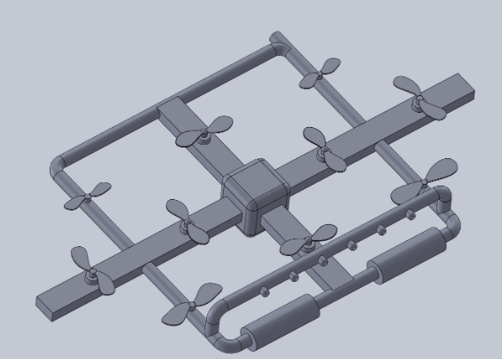

Figure 5: CAD Model

The selected design as shown in the above figure has used the strategy of 3:4:3 propellers, the front line contains 3 propellers, middle line contain 3 propellers, while the back line also contain 3 propellers. This firefighter’s drone is able to lift the complete drone, while the front side having the rotating thick rods will use to launch the shower system along with the water tank and the complete electronic assembly will build in the middle portion, while the camera will attach at the center of the drone. A pipeline has shown with the bars, these pipelines are representing the shower, the water will come from the round thick pipes which will attach the controller. The drone will connect with the hose to reel. The failsafe part of the device is that when the drone will be in the air, it will fail and in that case the drone will hold by the reel and the reel will automatically rotate quickly and slide the drone by the side of the road.

## 5.2 Implementation Plan

The implementation plan will perform in the next semester where we will build the prototype first to confirm the design functionality and then if any changes need to do in the design, will do that and after we will make the list of components that will need to order, will place the order then and when the components will arrive, test the components by connecting with each other and then when it has confirmed that every component is working properly, we will start assembling the products. As the drone structure need to build by hand so we will build the structure in the mechanical lab and then assemble all the parts on the drone structure. The complete schedule of the implementation plan has given below in the Gantt chart.

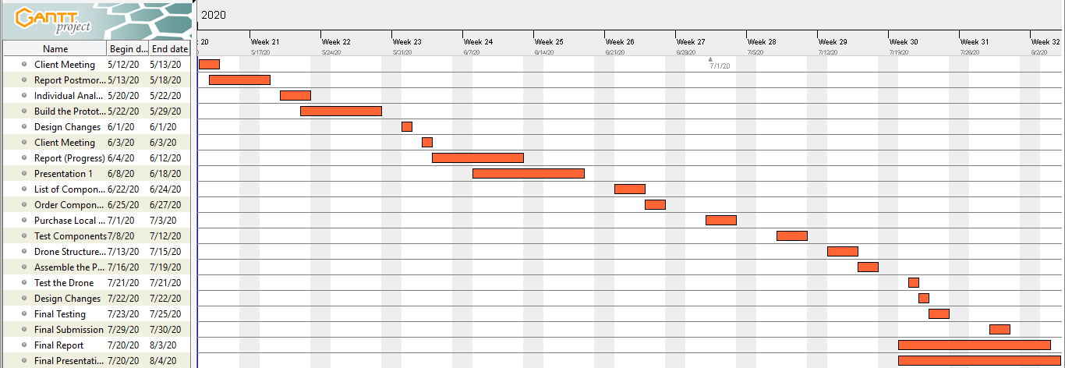

Figure 6: Gantt Chart

# 6 REFERENCES

[1] B. Marian, “Investigation of hydraulic fitting losses”, available [online], <https://www.researchgate.net/publication/325338468_Investigation_of_hydraulic_fitting_losses>

[2] M. Santosh, “Compartive study for Wiper Control System Using MATLAB”, available [online], <https://www.researchgate.net/publication/335524435_Comparative_Study_for_Wiper_Control_Systems_using_MATLAB_Tools>

[3] P. Imade, “Design, Production, and Testing”, available [online], <https://www.researchgate.net/publication/320244094_Design_Production_and_Testing_of_a_Single_Stage_Centrifugal_Pump>

[4] B. Mohammed”, Power Supply Architectures for Drones”, available [online], <https://www.researchgate.net/publication/336669179_Power_Supply_Architectures_for_Drones_-_A_Review>

[5] L. Leo, “Working Principle of Arduino and its tools”, available [online], <https://www.researchgate.net/publication/326316390_WORKING_PRINCIPLE_OF_ARDUINO_AND_USING_IT_AS_A_TOOL_FOR_STUDY_AND_RESEARCH>

# 7 APPENDICES

## APPENDIX A – DESIGN CALCULATIONS

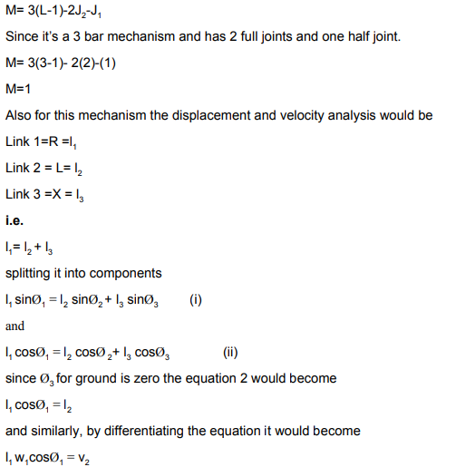

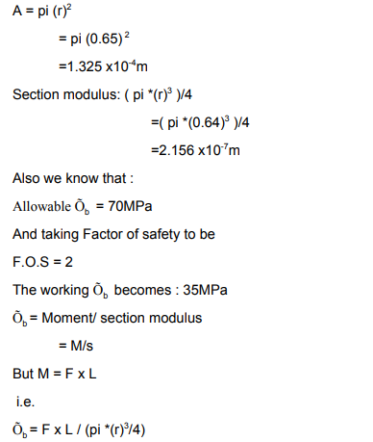

## APPENDIX B – FMEA

|  |  |  |  |  |  |  |  |  |  |
| --- | --- | --- | --- | --- | --- | --- | --- | --- | --- |
| Product Name | | Development Team | | | | Page No of | | | |
| System Name | | FMEA Number | | | |
| Subsystem Name | | Date | | | |
| Component Name |  |  | | | |
| Part # and Functions | Potential Failure Mode | Potential Effect(s) of Failure | Severity (S) | Potential Causes and Mechanisms of Failure | Occurrence (O) | Current Design Controls Test | Detection (D) | RPN | Recommended Action |
| **1 Controller** |  |  |  |  |  |  |  |  |  |
| 1.1 Controller Brun | Burning of Controller | Disconnection with Drone | 7 | 1. Bad quality of controller | 4 | 1. Over Voltage Test | 4 | 112 | Check the quality of controller |
| 1.2 Controller Transmitter | Burning of ransmiter | Disconnection with Drone | 6 | 1. Bad qualit of transmitter | 4 | 1. Over Voltage Test | 4 | 96 | Check the quality of controller |
| 1.3 Controller Reciever | Burning of Reciever | Disconnection with Drone | 6 | 1. Bad quality of reciever | 4 | 1. Over Voltage Test | 4 | 96 | Check the quality of controller |
| 1.4 Controller Body | Breaking of Body | Cracks and bends | 4 | 1. Bad quality of controller | 3 | 1. Over Pressure Test | 3 | 36 | Check the quality of controller |
| 1.5 Controller Board | Burning of board because of short circuit | Disconnection with Drone | 3 | 1. Bad quality of controller | 3 | 1. Over Voltage Test | 3 | 27 | Check the quality of controller |
| 1.6 Controller battery | battery Dead | Disconnection with Drone | 4 | 1. Bad quallity of battery cells | 4 | 1. Over Voltage Test | 4 | 64 | Check the battery qualty |
| 1.7 Controller Button | Button failure | Not working of specific function | 3 | 1. Bad quality of push button | 3 | 1. Over Pressure Test | 4 | 36 | Check the qulaity of button |
| 1.8 Controller Handle | Handle stick motion failure | Not working the directions | 3 | 1. Bad quality of handle | 3 | 1. Over Pressure Test | 3 | 27 | Check the quality of handle |
| 1.9 Controller Screen | Breaking of screen | No display | 3 | 1. Extra presure and bad quality | 3 | 1. Over Pressure Test | 2 | 18 | Protect the screen |
| 1.10 Controller Range | Failure of range abruptly | Low battery level | 3 | 1. Voltage excess and low level | 2 | 1. Over Voltage Test | 3 | 18 | Check the qulaity of battery |
| **2 Motor** |  |  |  |  |  |  |  |  |  |
| 2.1 Shaft | Bending of Shaft, Breakage of Shaft | wait for new shaft, cost increased | 7 | 1.Bad quality due to molding,  2. poor quality shaft is used | 4 | 1.Bad seeding, Poor Quality aluminum | 6 | 168 | Test various qualities if pipes available at same cost |
| 2.2 Motor Widing | Winding burn out | Cost increase | 8 | 1. bad quality of copper 2. poor windings 3. over voltage, over speed | 4 | 1. Speed test 2. Over voltage test | 5 | 160 | Check multiple motors and test them roguishly |
| 2.3 Motor Housing | Bending of Housing | Body trouble will cause extra cost | 2 | 1. Bad qulaty of steel | 3 | 1. Over Pressure Test | 2 | 12 | Check the qulaity of houisng |
| 2.4 Motor Wire | Wire Bunr out | Cost increase | 6 | 1. bad quality of copper 2. poor windings 3. over voltage, over speed | 4 | 1. Speed test 2. Over voltage test | 4 | 96 | Check multiple wires |
| 2.5 Motor Stator | Bending of stator | Cost increase | 2 | 1. Bad quality of steel | 1 | 1. Over Pressure Test | 3 | 6 | Check the qulaity of steel |
| 2.7 Motor Rotor | Bending of rotor | Cost increase | 3 | 1. Bad quality of steel | 1 | 1. Over Pressure Test | 3 | 9 | Check the qulaity of steel |
| 2.8 Motor Bearing | Slip of balls | Cost increase | 4 | 1. bad qulaity of bearing | 3 | 1. Over Pressure Test | 3 | 36 | Check the quality of bearings |
| 2.9 Motor Insulation | Buring of Insulation | Trouble in running the motor | 4 | 1. Bad quality of plastic insulator | 5 | 1. Over Voltage Test | 4 | 80 | Check the qulality of Insulator |
| 2.10 Motor Screws | Detach of screws | Vibrations cause removal of screws | 2 | 1. Bad quality of covering | 4 | 1. Over Pressure Test | 3 | 24 | Check the quailty of screws |
| **3 Arduino** |  |  |  |  |  |  |  | 0 |  |
| 3.1 Arduino Board | Burning of board | shorting of circuit | 5 | 1. unsecure circuit lining | 7 | 1. Over Voltage Test | 5 | 175 | Check the circuit lining |
| 3.2 Arduino Pins | Breaking of Pins | Over Pressure | 5 | 1. Pins not inserted Correctly | 7 | 1. Over Pressure Test | 4 | 140 | Check the pins |
| 3.3 Arduino Components | Breaking of Components | Over Pressure | 5 | 1. components break | 6 | 1. Over Pressure Test | 5 | 150 | Check the components properly |
| 3.4 Arduino Connections | Failed to connect | Code Issue | 6 | 1. code fixing | 7 | 1. Code fixing problem | 4 | 168 | Check the code reseting |
| 3.5 Arduino Reset | Failed to reset the board | Code Issue | 5 | 1. code fixing | 6 | 1. Code fixing problem | 5 | 150 | Check the reseting in the code |
| 3.6 Arduino Reciever | Reciever failed to responsd | Code issue or physical issue | 5 | Reciever not working properly | 5 | Antenna check | 7 | 175 | Reciever Check |
| 3.7 Arduino Transmitter | Failed to send the data | Code issue or physical issue | 5 | Transmittor not workin properly | 5 | Antenna check | 7 | 175 | Transmittor check |
| 3.8 Arduino Power Source | Power source burning | Power source burning | 4 | Burning of source may break | 4 | 1. Over Voltage Test | 6 | 96 | Power source check |
| 3.9 Arduino adoptor | burning of adoptor | Power source burning | 4 | Power adoptor burns | 4 | 1. ove voltage test | 5 | 80 | check the adoptor |
| 3.10 Arduino heat sink | Burning of heat sink | Heat sin cause trouble | 5 | Bad qualiyf of heat sink | 3 | 1. Over Voltage Test | 5 | 75 | check the heat sink quality |
| **4 Batteries** |  |  |  |  |  |  |  | 0 |  |
| 4.1 Over voltage | Producing over voltage caussing other devices to burns | Over Current | 5 | Bad quality of battery cells | 5 | 1. Over Voltage Test | 6 | 150 | Check quality of battery cells |
| 4.2 Over Current | Producing over current | Over Voltage | 5 | Bad qaulty of battery cells | 5 | 1. Over Current Test | 6 | 150 | Check quality of battery cells |
| 4.3 Battery | Burning of battery | Over Voltage | 5 | Bad quality of battery cells | 5 | 1. Over Voltage Test | 5 | 125 | Check battery quality |
| 4.4 Battery Cover | Breaking of cover | Over Pressure | 2 | Bad quality of plastic | 4 | 1. Over Pressure Test | 4 | 32 | Check qualty of cover |
| 4.5 Battery storage | Fail to store | Cells burning | 4 | Bad qulality of cells | 3 | 1 Over Voltage test | 4 | 48 | Storage quality |
| 4.6 Battery Positive Terminal | Breaking of termial | Over Pressure | 3 | bad qualty of terminal | 4 | 1. Over Pressure Test | 4 | 48 | Battery Terminal |
| 4.7 Battery Negative Terminal | Breaking of Terinal | Over Pressure | 3 | Bad quality of terminal | 4 | 1. Over Pressure Test | 4 | 48 | Battery Terminal |
| 4.8 Battery Low output | Less voltage apperas at the output | Cells burning | 5 | Bad qulaiy of cells | 4 | 1. Over Voltage Test | 4 | 80 | Battery check quality |
| 4.9 Battery Swell | Burning of cells | Over Voltage issue | 8 | Time period of battery | 4 | 1. Over Voltage Test | 3 | 96 | check the battery life |
| 4.10 Battery connections | Burning of battery internal connections | Over Voltage issue need to recover | 5 | Bad quallity of cells | 4 | 1. Over Voltage Test | 4 | 80 | Check the battery qualty |